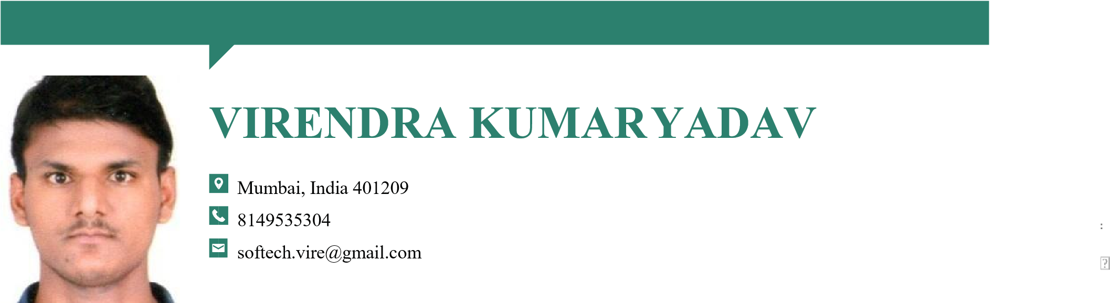

|  |  |  |
| --- | --- | --- |
| **SUMMARY** | Dedicated QA Automation bringing 4.3 years of experience and diligence to handle needs of large and complex products. Solid history in both manual and automated testing. Seek to apply expertise to growth-oriented, dynamic position.  Having aggressive to learn the new tools and technology which are more entertaining to our mind. | |
| **SKILLS** | * Manual Testing * Scenarios and writing Cases * Automated Testing Frameworks * Test Plans and Test Methodologies * Defect Tracking and Reporting * Continuous-Integration Testing * Teamwork and Positive Attitude * Web and Mobile Application QA | * Scrum Methodology * Software Development Tools: JIRA, Confluence * Programming Languages: Java, HTMl Some knowledge of JS. * Tools: Selenium,Cypress,MYSQl,Postman,   Eclipes ,Inteli-j, VS code,android Studio,Appium.   * Remote Tools: Git,GitHub, AzureDevops, GitLabs * Knowledge of Mobile Testing * Having good Knowledge SQl and API testing by Postman tools * Fremworks: POM, TestNG, BDD-Cucumber, API-Automation. |

**EXPERIENCE QA AUTOMATION ENGINEER**, 01/2022 – Current

***Data Technology and Processing Corporation (INN-FLOW)***, Gurugram,Haryana, India

* Produced test scripts for new automated software testing rounds.
* Wrote and updated manual test cases for team use, maintaining optimal organization for maximum productivity and merge them and go for automation testscript.
* We also fellow agile so that we go on that process and fellow every steps like meetings ,documentation and whatever prerequisite we have to prepare.
* I have witting end to end testcases and verify data as per task whatever i have provided.
* Created and optimized automated testing tools for repetitive tasks for regression.
* also prepare smoke testcases to automation.

**QA ENGINEER**, 08/2019 - 12/2021

***SM Web Solutions Pvt. Ltd***, New Delhi, India

* Collaborated with quality team members and leaders to monitor conformance to quality standards.
* Drafted process to standardized the writing of testscripts and techniques.
* Supported QA Automation team in implementing corrective actions to increase quality.
* Having good collaborations to our manual team member.

**PROJECTS Konga.com (*E-Commerce*)** *(08/2019 to 10/2020)*

***Discription*** **Konga** is Nigeria's number one online shopping destination where you can shop the widest selection of   
 electronics, fashion, home appliances, kid's items and more in Nigeria and have them shipped directly to   
 your home or office at your convenience! We offer free nationwide delivery, free returns.

**Rout4me(*Locality* )** *(10/2020 to 05/2021)*

***Discription*** Route4me is an online Web service organisation that tells you the most efficient route to complete all .   
 your errands, just put in the addresses, and let it work its magic. Route4me optimizes your route when   
 traveling to multiple destinations, allowing you to enter up to 200 addresses per route. Route4me   
 claims that routes are usually shorter after being optimized. You can map the fastest or shortest path .   
 with Route4Me. The app could be particularly helpful for small business owners who regularly make   
 multiple deliveries in a single trip. You could eyeball the map to pick the best route

**Info crm (*Back End Application*)** *(06/2021 to 12/2021)*

***Discription*** ***info crm*** is a back end application of organization , we have to here chake GUI as well as backend data   
 and also chake API testing of the application .Its all about application making for manage the organization   
 details.

**Inn-flow.com (*Hotel Management*)** *(08/2019 to 10/2020)*

***Descriptions*** It’s a US based Hotel management product-based application, inside we maintain Sales and Procurements   
 and We also maintain the Labour Data and all things related and also maintaining accounts.

**EDUCATION AND *Subharti University ,*** *Meerut ,UP, 12/2022*

**TRAIING Master of Computer Application**

***Thakur College of Science and commerce,*** *Kandivali (west), Mumbai, 05/2016*

***Bachelor of Science: Science***

***Lokmanya Junior College,*** *Vijay Nagar, Nallasopar, Mumbai., 05/2016* **12th**: **Science**

***SMPDI College****, Manikpur, UP, 05/2014*

**10th**: **Science**

**LANGUAGES**

**English:** **Hindi:**

Intermediate Intermediate

**PERSONAL DETAILS Date of Birth :** *15-04-1998*

**Father’s Name :** *Mr.Kripashankar Yadav*

**Marital Status :** *Unmerried*

**Gender :** *Male*

2/2